Technical Datasheet Input / Output Modules with Modbus RTU Protocol with RS485 Interface

4DDAPM Module: -

The RS485 IO module is a compact, robust, and low-power device designed for reliable communication over distances up to 700 meters without a repeater, depending on the signal strength of the Modbus master. It features 4 digital inputs, 4 digital outputs, 4 analog inputs (10-bit resolution, supporting 0–20 mA and 0–10 V), and 4 RTD (PT1000) channels, making it ideal for versatile industrial applications. Housed in a DIN rail-mountable enclosure, the module includes exposed connectors for easy wiring and LED indicators for real-time I/O status monitoring. Configuration of slave ID and baud rate is done via internal DIP switches. To enhance system protection, the module is equipped with resettable fuses guarding against reverse polarity on both power and RS485 communication ports.

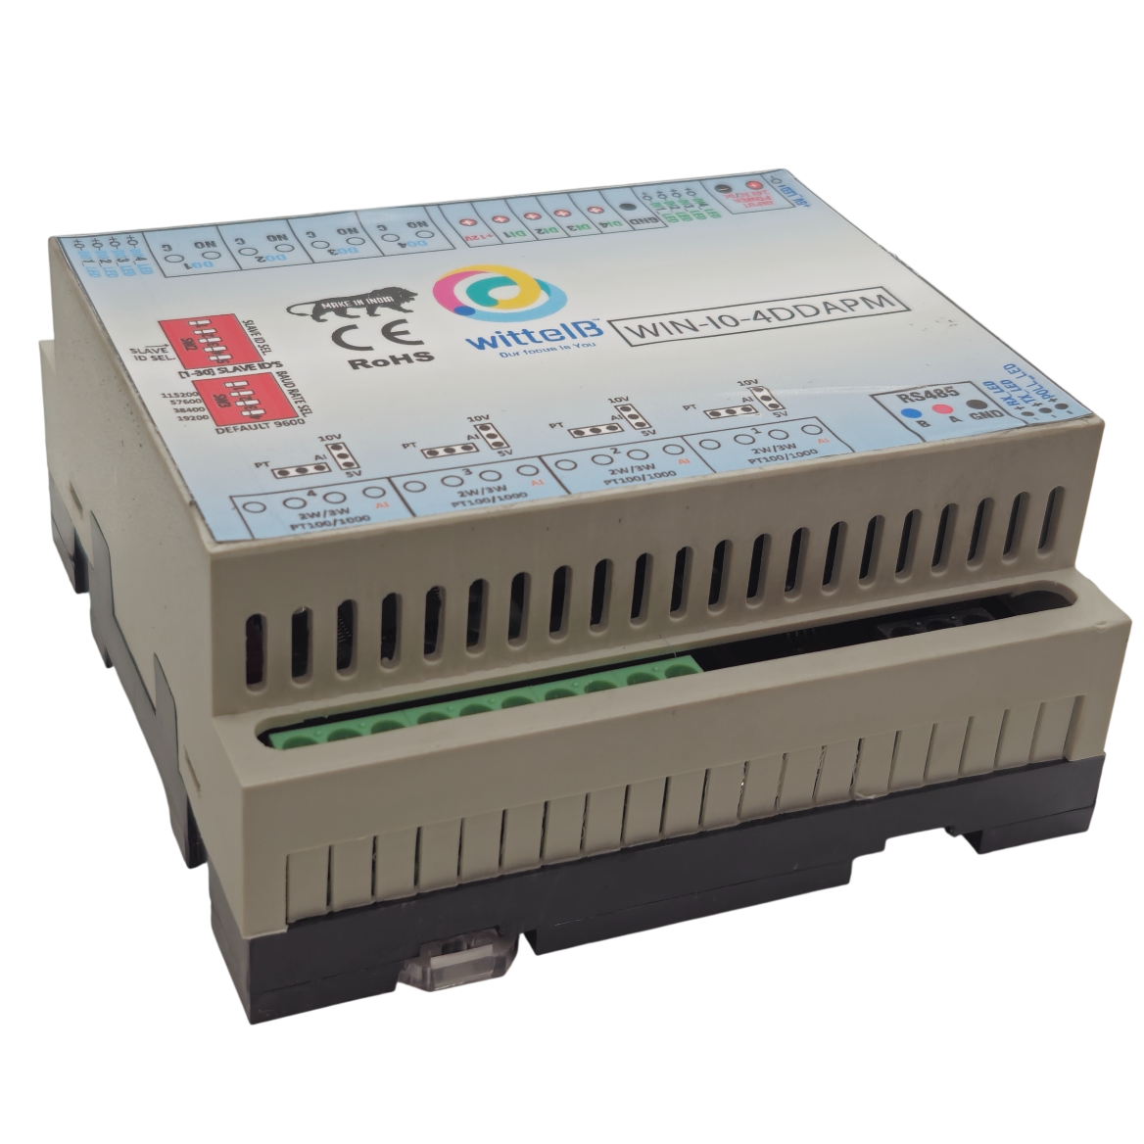

Specifications
General –
I/O Connectors 30 Pin 5.08 mm pitch pluggable screw Terminal Block, 2 Pin 5.08 mm pitch pluggable screw terminals.
Dimensions 110 mm L x 110 mm B x 50 mm H
Power Input Power – 12 - 24 VDC
Typical – 12V DC @ 120mA
Operating Temperature 0 – 60° C (32 ~ 140°F)
Storage Temperature -20 - 70° C (-4 ~ 158°F)
Storage Humidity 5 ~ 95 % RH, non – Condensing
Certifications 

DI Inputs –
Channels 4
Sense Voltage 3.3 – 30 VDC
Sense Logic Logic ‘0’ = <1 VDC, Logic ‘1’ = >3.3 VDC
Isolation Optically isolated
Response Time 2 msec, Max 6 msec

Digital Output
Channels 4
Output Type P-Channel MOSFET
Channel Voltage 12 VDC
Channel Current 20A
Channel Power 240 W (max)
Operating Time 2.8ns.
Turn Off delay Time 33.5ns.
Operating Temperature -55℃~+150

AI Inputs –
Channels 4
Input Signal 4 – 20 mA / 0 – 10VDC
Accuracy ± 2% Full scale
Input Resolution 10 bits
Isolation Optically Isolated
External Loop Voltage + 12 VDC min
AI input impedance 120Ω

AI Inputs –
Channels 4 – PT1000 – (jumper selectable) Three wire
Accuracy Total Accuracy over All Operating Conditions: 0.5NC
(0.05% of Full Scale) max.

Input Resolution 15-Bit ADC Resolution.
Isolation Optically Isolated.

Additional Features: -
All inputs and communication ports isolated
Input power reverse polarity safety
ESD Safety IEC 61000-4-2, ± 30KV contact, ± 30KV air
EFT IEC 61000-4-4, 50A (5/50ms)
750V isolation.
CRC Error check.
No configuration needed on the IO board

Configuration Settings: -
Communication Speed 9600 – 115200 (DIP SW selectable)
Data Bits 8
Parity None
Stop bit 1
CRC Yes
Slave ID Configurable with DIP Switch
Function code DO 0x05 and 0x0F (5 Single coil & 15 multiple coil)
DO Register Address 0,1,2,3.
Function code DI 0x02 Read discrete Input
DI Register Address 4,5,6,7.
Function Code AI 0x03 Read Holding Registers
AI Register Address 10 Bit - 1,2,3,4.
RTD Register Address 5,6,7,8.
ID | Function  Description | Register  Description | Modbus Function Code | Protocol | Data  Type
1 | DO 1 | 00001 | 0X05,0X0F | RS485 | 1 Bit Boolean
2 | DO 2 | 00002 | 0X05,0X0F | RS485 | 1 Bit Boolean
3 | DO 3 | 00003 | 0X05,0X0F | RS485 | 1 Bit Boolean
4 | DO 4 | 00004 | 0X05,0X0F | RS485 | 1 Bit Boolean
5 | DI 1(With & Without Potential) | 10005 | 0X02 | RS485 | 1 Bit Boolean
6 | DI 2(With & Without Potential) | 10006 | 0X02 | RS485 | 1 Bit Boolean
7 | DI 3(With & Without Potential) | 10007 | 0X02 | RS485 | 1 Bit Boolean
8 | DI 4(With & Without Potential) | 10008 | 0X02 | RS485 | 1 Bit Boolean
9 | AI 1 | 40002 | 0X03 | RS485 | 16 Bit Unsigned int
10 | AI 2 | 40003 | 0X03 | RS485 | 16 Bit Unsigned int
11 | AI 3 | 40004 | 0X03 | RS485 | 16 Bit Unsigned int
12 | AI 4 | 40005 | 0X03 | RS485 | 16 Bit Unsigned int
13 | RTD1 1000 | 40006 | 0X03 | RS485 | 16 Bit Unsigned int
14 | RTD2 1000 | 40007 | 0X03 | RS485 | 16 Bit Unsigned int
15 | RTD3 1000 | 40008 | 0X03 | RS485 | 16 Bit Unsigned int
16 | RTD4 1000 | 40009 | 0X03 | RS485 | 16 Bit Unsigned int

Note: -
For MODBUS communications, a shielded and twisted pair cable is used. One example of such cable is Belden 3105A.
Recommended Cable Electrical Characteristics: -
22 AWG Cable Shielded and twisted pair should be used.
Tinned Copper Recommended
Nominal Conductor DCR 14.7 ohm / 1000 ft
Nominal Capacitance 11 pf / feet (conductor to conductor)
High Frequency Non-Insertion Loss 0.5db / 100ft

AI

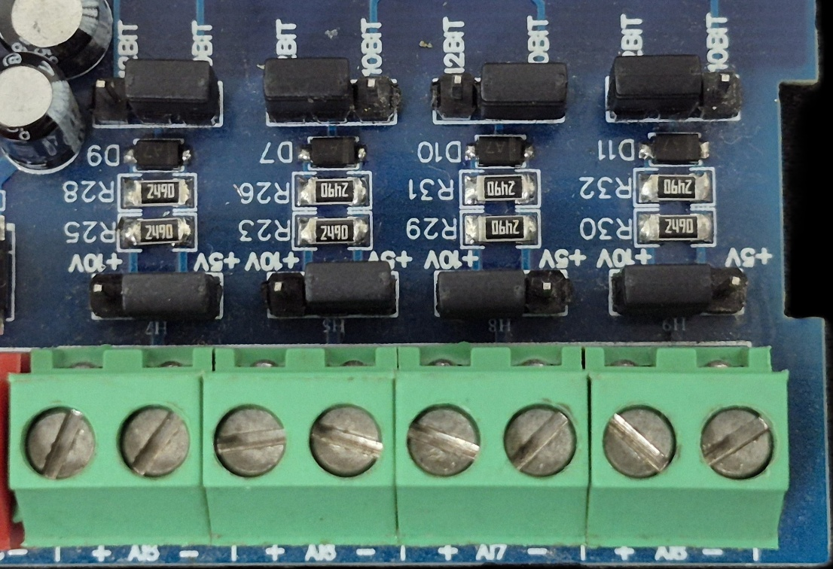
Sensor
Sensor
Sensor
Sensor

- Analog Input (AI) Operation: Each channel provides two terminals: + (Positive) and - (Negative/Common). These are used to read external analog sensor signals.
- Channel Configuration (Visual Guide): Each of the four AI channels features two dedicated jumpers to independently set the voltage range and bit resolution. Refer to the color-coded boxes in the board diagram to configure your desired scenario:
  - Red Box (5V, 10-bit): Set the voltage jumper to +5V and the resolution jumper to 10 BIT.
  - Green Box (5V, 12-bit): Set the voltage jumper to +5V and the resolution jumper to 12 BIT.
  - Blue Box (10V, 10-bit): Set the voltage jumper to +10V and the resolution jumper to 10 BIT.
  - Yellow Box (10V, 12-bit): Set the voltage jumper to +10V and the resolution jumper to 12 BIT.
- Sensor Wiring Connections:
  - The analog sensor's positive signal wire should be connected to the + terminal of the desired channel.
  - The sensor's common or ground wire should be connected to the corresponding - terminal.
- Crucial Setup Recommendation: Always ensure that the voltage jumper setting strictly matches the maximum output range of your connected sensor (either 5V or 10V) to guarantee accurate analog-to-digital conversion and prevent data clipping.
DO

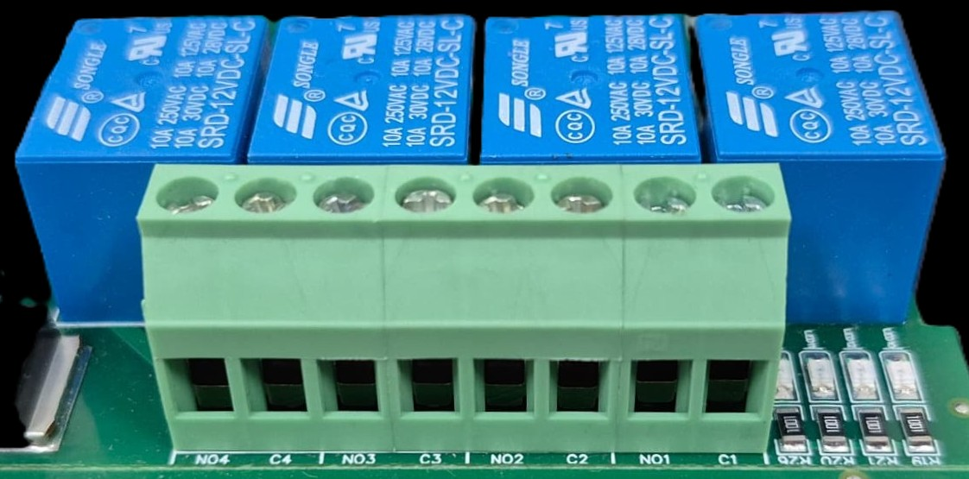





L
O
A
D
N

P
L
O
A
D
N

P
L
O
A
D
N

P
L
O
A
D
N

P

- Digital Output (DO) operation: Each channel provides two terminals: C (Common) and NO (Normally Open). When the relay coil is energized, terminal C is internally connected to NO, allowing current to flow. When the relay is de-energized, the connection between C and NO remains open, and the load stays OFF.
- Load Wiring Connections:
  - AC Load Connection: The AC Live (Phase) wire should be connected to terminal C. The load is connected between terminal NO and Neutral (N).
  - DC Load Connection: The positive supply (+V) should be connected to terminal C. The load is connected between terminal NO and Ground (GND).
- Crucial Safety Recommendation and Rating: It is strongly recommended to switch the Live (Phase) conductor in AC applications to ensure the load is safely de-energized when the relay is off.
Note: Ensure that the connected load does not exceed the relay’s contact rating of 10A @ 250VAC (or 10A @ 125VAC) or 10A @ 30VDC (or 10A @ 28VDC).

BAUD RATE DESCRIPTION

LSB
MSB
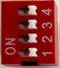

- For Baud rate Selection, DIP SW is used as per the diagram.
- Pulling up the switch will make Baud rate active.
- If no selection is made 9600 will be default Baud rate.
- When u change the Baud rate in the Module power ‘ON’ condition,
pls press the reset button to get Change to affect.

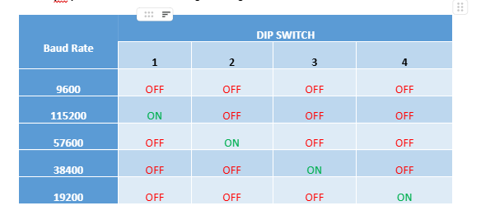

SLAVE ID DESCRIPTION

MSB
LSB
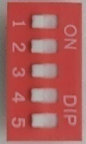

For Slave ID Selection SW is used to Set The SLAVE ID .
For Slave ID DIP Switch LSB is “1” follow through “5” is MSB.
Slave ID Confirmed through below Device ID table .
IF Eg. Slave ID 1 is Needed to be selected Switch number 1 should pulled up other three should be selected down side. So”1 0 0 0” will be selected as Slave ID 1.

Note: DIP switches SW1 to SW5 are provided for user configuration. These switches can be set as per the application requirements to control functions such as slave address selection, mode settings, or other device parameters.
Note: The device supports configurable slave addresses within the range of 1 to 31, which can be set according to application requirements.

Slave ID | DIP SWITCH |  |  |  | OUTPUT (Binary) | OUTPUT (Decimal)
 | 1 | 2 | 3 | 4
0 | OFF(0) | OFF(0) | OFF(0) | OFF(0) | 0 0 0 1 | 1
1 | ON(1) | OFF(0) | OFF(0) | OFF(0) | 0 0 0 1 | 1
2 | OFF(0) | ON(1) | OFF(0) | OFF(0) | 0 0 1 0 | 2
3 | ON(1) | ON(1) | OFF(0) | OFF(0) | 0 0 1 1 | 3
4 | OFF(0) | OFF(0) | ON(1) | OFF(0) | 0 1 0 0 | 4
5 | ON(1) | OFF(0) | ON(1) | OFF(0) | 0 1 0 1 | 5
6 | OFF(0) | ON(1) | ON(1) | OFF(0) | 0 1 1 0 | 6
7 | ON(1) | ON(1) | ON(1) | OFF(0) | 0 1 1 1 | 7
8 | OFF(0) | OFF(0) | OFF(0) | ON(1) | 1 0 0 0 | 8
9 | ON(1) | OFF(0) | OFF(0) | ON(1) | 1 0 0 1 | 9
10 | OFF(0) | ON(1) | OFF(0) | ON(1) | 1 0 1 0 | 10
11 | ON(1) | ON(1) | OFF(0) | ON(1) | 1 0 1 1 | 11
12 | OFF(0) | OFF(0) | ON(1) | ON(1) | 1 1 0 0 | 12
13 | ON(1) | OFF(0) | ON(1) | ON(1) | 1 1 0 1 | 13
14 | OFF(0) | ON(1) | ON(1) | ON(1) | 1 1 1 0 | 14
15 | ON(1) | ON(1) | ON(1) | ON(1) | 1 1 1 1 | 15

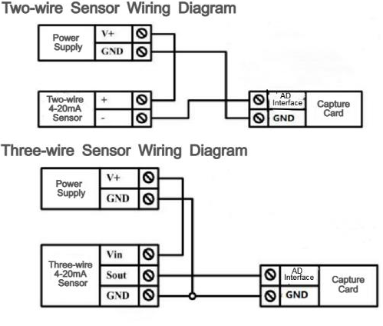
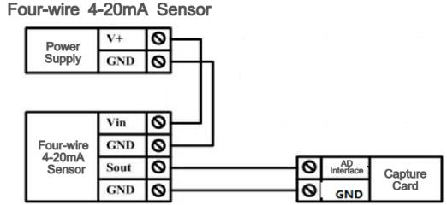

1 2 3 4
AI / PT 1000 Channel

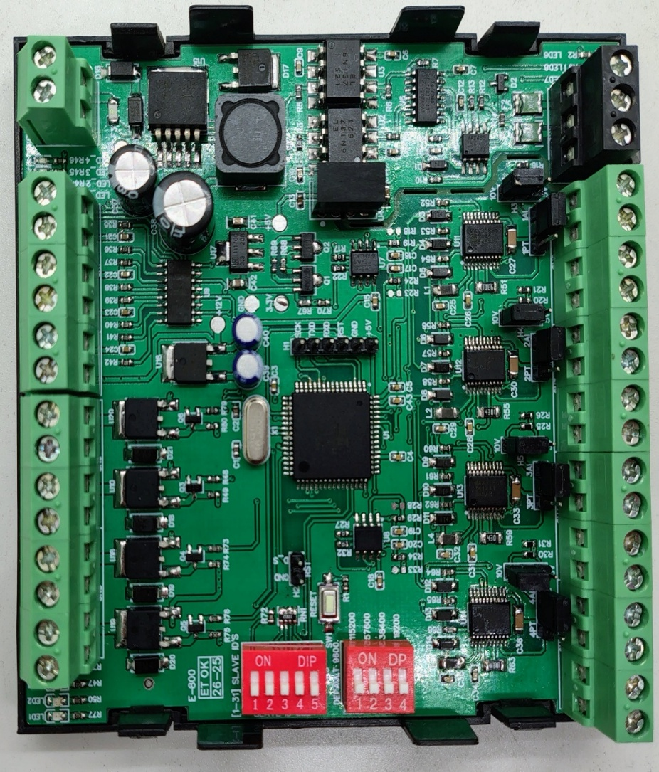
+12V Reference Voltage
Input 12-24 VDC
SLAVE ID
BAUD
RATE
5V/10V
Jumper
AI/PT
Jumper
Modbus RS485
DO4 DO3 DO2 DO1
DO Channel
DI4 DI3 DI2 DI1
DI Channel
Common
GND

Contact Information
Augmatic Technologies Pvt. Ltd.,
Plot no 6, Shah Industrial Estate II,
Kotambi,
Vadodara – 391510.
Email – Sales@wittelb.com
Support E.: support@wittelb.raiseaticket.com / M.: 9403892805

